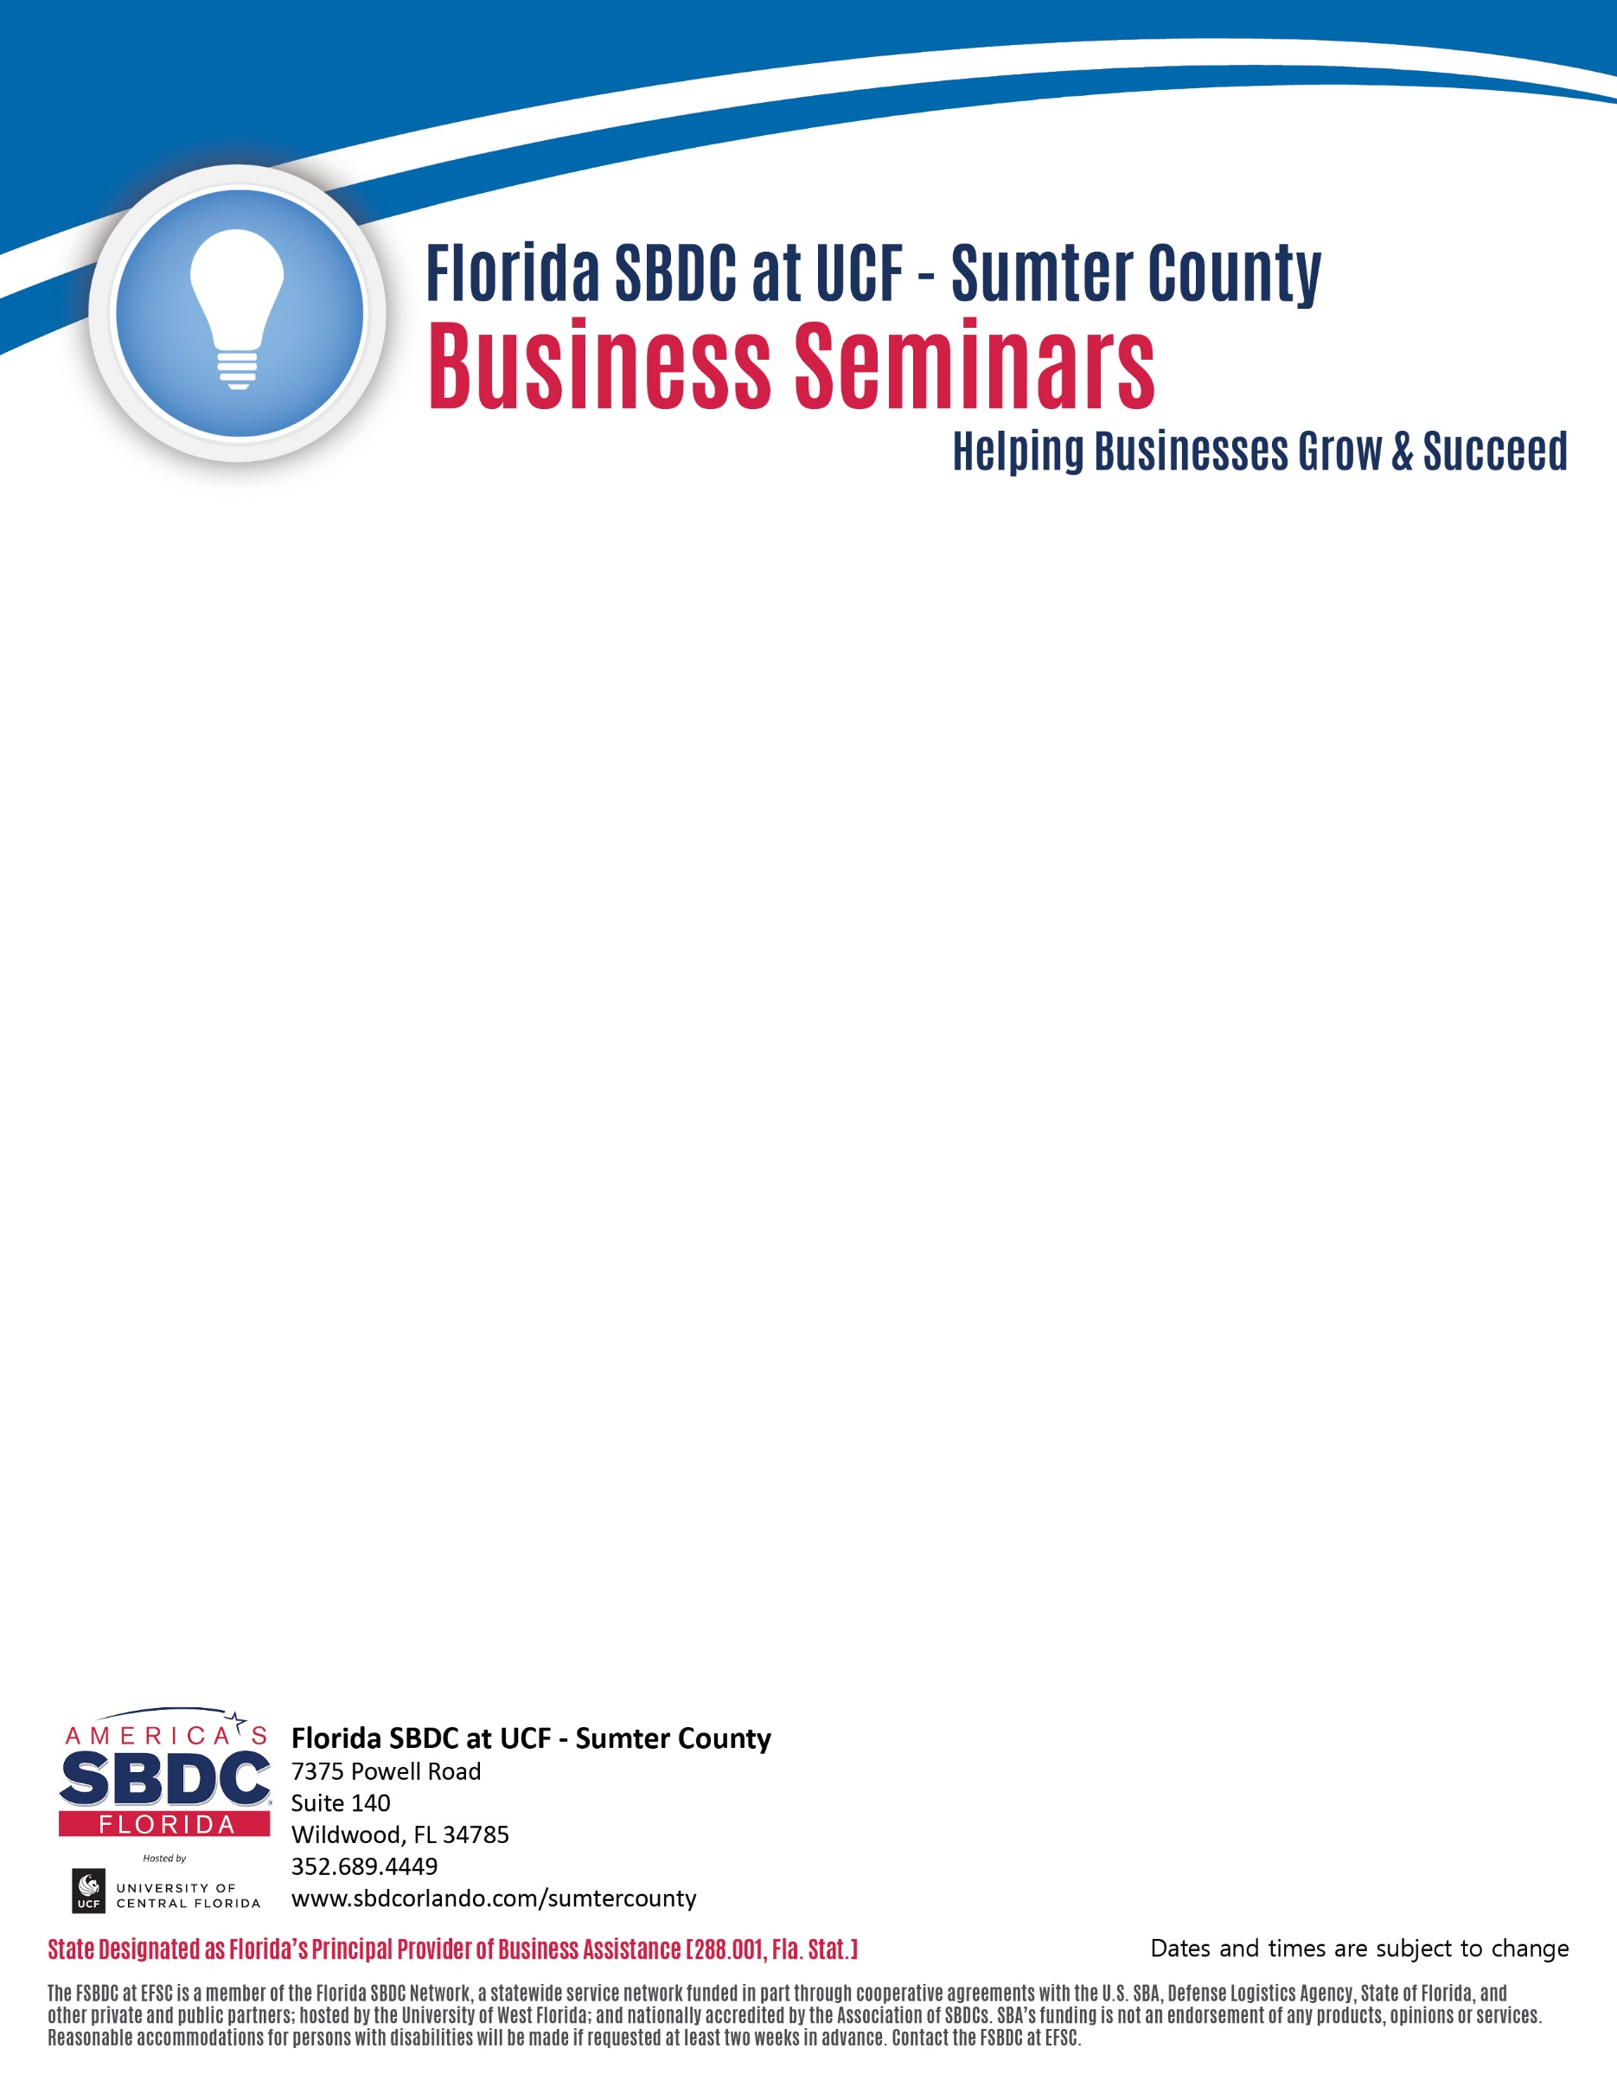

**When:**

August 8, 2017/ 5:00 to 7:30 PM [**Click here to Register online**](https://fsbdc.net/EventsUR/580370021)

August 15, 2017/ 9:00 to 11:30 AM **[Click here to Register online](https://fsbdc.net/EventsUR/580370022)**

**Where**:

7375 Powell Road, Room 102, Wildwood, FL 34785

Phone: **352-689-4698** Call with any questions or register.

**STARTING OR GROWING YOUR BUSINESS?**

**We Have the Tools You Need to Succeed**

In this **NO-COST** seminar, we will provide you the expertise, resources and tools to help your business grow and succeed.  If you are not reaching your goals then join this seminar and learn the following:

* Understanding business structures
* Developing a business plan
* Marketing your products or services
* Using financial concepts

We can jump start your business thinking process to put infrastructure and plans in place to increase your profits and long-term growth.

Our promise is to present the basic elements and steps needed to wisely and efficiently start and grow a business in Sumter County.  If you are looking to make better business decisions, our training is a good first step.